**THE FIRST PRESBYTERIAN CHURCH**

**OF LANSING**

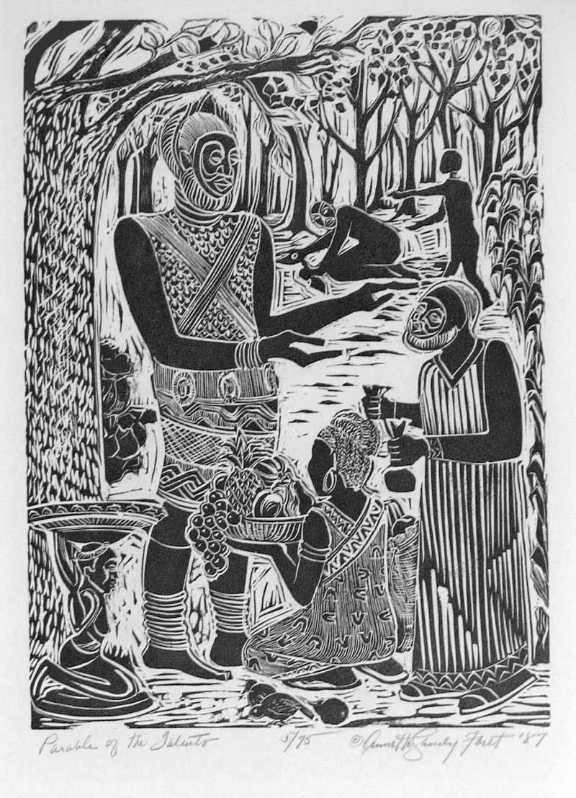

“Parable of the talents,” Annette Gandy Fortt, Vanderbilt Divinity Library

**510 W. Ottawa Street ▪ Lansing, Michigan 48933**

**(517) 482-0668** [www.lansingfirstpres.com](http://www.lansingfirstpres.com)

Facebook – Lansing First Presbyterian

**Church Office Hours (M-F) 8:00 a.m. – 12:00 & 1:00 p.m. – 4:00 p.m.**

**SERVICE FOR THE LORD’S DAY**

Nov. 19, 2023 10:00 a.m.

Twenty-fifth Sunday After Pentecost

**WELCOME AND ANNOUNCEMENTS**

*In order to maintain our worship environment, please turn off your cell phones. Thank you.*

**PRELUDE**  Sergei Kvitko

**CALL TO WORSHIP** Fred Lowe

To you, O God of the heavens, we lift our eyes.

**Have mercy on us!**

God has been our dwelling place from generation to generation.

**Hear us when we call!**

From everlasting to everlasting, God is with us.

**We will magnify your holy name!**

**++HYMN #4 [GTG]** Holy God, We Praise Your Name

*Based on an 18th-century German metrical version of a celebrated 15th-century Latin hymn, Te Deum laudamus, this abbreviated 19th-century English paraphrase is sung by both Protestants and Roman Catholics. It is set here to the tune composed and named for the German version.*

**SERVICE OF RENEWAL**

Call to Confession Fred Lowe

Unison Prayer of Confession

**God of abundance,**

**you have given us so many gifts.**

**You bless us with talents, resources,**

**skills, and knowledge,**

**and yet we hide them under a bushel.**

**We hoard these gifts, instead of following you**

**and sharing with those in need.**

**We have been poor stewards of all you have given.**

**Forgive us, and help us grow what we are given,**

**that it might be returned in service to you.**

**++**indicates to stand in body or spirit

Assurance of Pardon Fred Lowe

God has destined us not for wrath,

but for salvation through our Lord Jesus Christ,

who died for us so that we may live with him.

**Praise be to Christ! Alleluia!**

++Response to Forgiveness #**447[GTG]** We Are Forgiven

***We are forgiven. We are forgiven.   
Thanks be to God. Thanks be to God.  
We are forgiven. We are forgiven.   
Thanks be to God. Thanks be to God.***

**++PASSING THE PEACE OF CHRIST**  Fred Lowe

May the peace of our Lord Jesus Christ be with you.

**And also with you.**

***Be still and know that I am God***

***Be still and know that I am God***

***Be still and know that I am God***

**CHILDREN’S MOMENT** Ms. Megan

**PRAYER FOR ILLUMINATION** Fred Lowe

Sovereign God, let your Word rule in our hearts

and your Spirit govern our lives

until at last we see the fulfillment

of your realm of justice and peace;

through Jesus Christ our Lord.

**Amen.**

**OLD TESTAMENT LESSON** Psalm 90:1-8, 12 Fred Lowe

1Lord, you have been our dwelling place in all generations.

2Before the mountains were brought forth, or ever you had formed the earth and the world, from everlasting to everlasting you are God.

3You turn us back to dust, and say, “Turn back, you mortals.”

4For a thousand years in your sight are like yesterday when it is past, or like a watch in the night.

5You sweep them away; they are like a dream, like grass that is renewed in the morning;

6in the morning it flourishes and is renewed; in the evening it fades and withers.

7For we are consumed by your anger; by your wrath we are overwhelmed.

8You have set our iniquities before you, our secret sins in the light of your countenance.

12So teach us to count our days that we may gain a wise heart.

The Word of the Lord.  **Thanks be to God.**

**ANTHEM** Bells of First

**GOSPEL LESSON** Matthew 25:14-30 Rev. Stan Jenkins

14“For it is as if a man, going on a journey, summoned his slaves and entrusted his property to them; 15to one he gave five talents, to another two, to another one, to each according to his ability. Then he went away. 16The one who had received the five talents went off at once and traded with them, and made five more talents. 17In the same way, the one who had the two talents made two more talents. 18But the one who had received the one talent went off and dug a hole in the ground and hid his master’s money. 19After a long time the master of those slaves came and settled accounts with them. 20Then the one who had received the five talents came forward, bringing five more talents, saying, ‘Master, you handed over to me five talents; see, I have made five more talents.’ 21His master said to him, ‘Well done, good and trustworthy slave; you have been trustworthy in a few things, I will put you in charge of many things; enter into the joy of your master.’ 22And the one with the two talents also came forward, saying, ‘Master, you handed over to me two talents; see, I have made two more talents.’ 23His master said to him, ‘Well done, good and trustworthy slave; you have been trustworthy in a few things, I will put you in charge of many things; enter into the joy of your master.’ 24Then the one who had received the one talent also came forward, saying, ‘Master, I knew that you were a harsh man, reaping where you did not sow, and gathering where you did not scatter seed; 25so I was afraid, and I went and hid your talent in the ground. Here you have what is yours.’ 26But his master replied, ‘You wicked and lazy slave! You knew, did you, that I reap where I did not sow, and gather where I did not scatter? 27Then you ought to have invested my money with the bankers, and on my return I would have received what was my own with interest. 28So take the talent from him, and give it to the one with the ten talents. 29For to all those who have, more will be given, and they will have an abundance; but from those who have nothing, even what they have will be taken away. 30As for this worthless slave, throw him into the outer darkness, where there will be weeping and gnashing of teeth.’

**SERMON**   Rev. Stan Jenkins

**++HYMN #494 [GTG]**  Jesus, Thou Joy of Loving Hearts

*This 19th-century American translation of stanzas from a longer Latin poem is so well shaped that it sounds like an original meditation on Christian experience centered on the Lord’s Supper. The North American tune name seems not to have originated with the English composer (QUEBEC).*

**PRAYERS OF THE PEOPLE** Gwen Botting

The Lord be with you

**And also with you.**

Lift up your hearts.

**We lift them up to the Lord.**

Let us give thanks to the Lord our God.

**It is right to give our thanks and praise.**

(Prayers continue)

Lord’s Prayer **(unison)**

**Our Father who art in heaven, hallowed be thy name. Thy kingdom come, thy will be done, on earth as it is in heaven.  Give us this day our daily bread; and forgive us our debts, as we forgive our debtors; and lead us not into temptation, but deliver us from evil.  For thine is the kingdom and the power and the glory, forever.  Amen.**

Choral Response

***Amen, Amen, Amen.***

**PRESENTING OUR GIFTS**

**CHORAL ANTHEM** “I’d Rather Have Jesus” arr Marrianne Forman

w/Karen Viele, violin

*I’d rather have Jesus than silver or gold; I’d rather be His than have riches untold;*

*I’d rather have Jesus than house or lands, I’d rather be led by His nail-pierced hands.*

*Than to be the king of a vast domain, or be held in sin’s dread sway.*

*I’d rather have Jesus than anything this world affords today.*

*I’d rather have Jesus than men’s applause; I’d rather be faithful to His dear cause;*

*I’d rather have Jesus than worldwide fame. I’d rather be true to His holy name.*

*He’s fairer than lilies of rarest bloom; He’s sweeter than honey from out of the comb;*

*He’s all that my hungering spirit needs, I’d rather be His and let Him lead.*

*Than to be the king of a vast domain, or be held in sin’s dread sway.*

*I’d rather have Jesus than anything this world affords today.*

**Offering**

**++ Doxology #717[GTG]** “For the Life That You Have Given”

***For the life that you have given, for the love in Christ made known.***

***With these fruits of time and labor, with these gifts that are your own:***

***Here we offer, Lord our praises; heart and mind and strength we bring;***

***Give us grace to love and serve you, living what we pray and sing.***

**Prayer of Dedication**

**++HYMN #673 [GTG]** Jesus, Light of Joy

*The images of light in this text are drawn from the ancient Chinese vesper hymn Phos hilaron, which dates from at least the 3rd century. (For other versions, see hymn no.’s 671 and 672). That rather brief original hymn is augmented here in the third stanza by language based on the Sanctus (Holy, Holy, Holy).*

**BENEDICTION**

**BLEST BE THE TIE 306[GTG]**

***Blest be the tie that binds our hearts in Christian love:***

***The fellowship of kindred minds is like to that above.***

**POSTLUDE**   Sergei Kvitko

*PLEASE BE AWARE THAT WE USE CAMERAS TO BROADCAST VIDEO OF OUR

CHURCH SERVICES. Licensed music streamed with permission under ONE LICENSE, License #A-731144. All rights reserved."





**INFORMATION FOR THE DAY**

Participants in this morning’s service:

Liturgist Fred Lowe

Organist/Pianist Sergei Kvitko

Director of Music Megan Higle

Bells of First Director Darin Showalter

Dir. Church Life/Comm. Outreach Prince Solace

Pastor Rev. Stanley Jenkins

Concerns of the congregation:

In care facilities: Jean Dietrich (Story Point of Grand Ledge) Dianne Rector (Rosewood Adult Foster Care- DeWitt)

**LARGE PRINT BULLETINS** are available.

**Flowers today are in honor of Fred Lowe, by Chrisann Lowe, for his birthday.**

**FLOWER CHART**  There are many dates available on the chart to celebrate special days in our church family.  The new price is $50. Simply sign up on the chart (in the office hall), indicate the occasion that you would like celebrated or honored (birthday, anniversary or memorial), write a check to the church and give it to Betsy, and we will order for you.  If you would like to purchase or provide a silk arrangement for use when we don’t have a fresh arrangement scheduled, please see Judy Whitman.  Thank you!  - Worship Committee.

**"YOUR SUPPORT IS VITAL TO OUR MISSION! PLEASE SCAN THIS CODE WITH YOUR SMARTPHONE TO GIVE SECURELY ONLINE." Take a picture with your phone and it will take you to the website to make a donation.**



**THIS WEEK AT A GLANCE**

**Sunday, November 19**

10:00 a.m.       Morning Worship – SANCTUARY

11:30 a.m. Adult Forum – LITTEN HALL

11:30 a.m. Children’s Faith Formation

12:30 p.m. Victory in Jesus Ministries Worship – SANCTUARY

3:00 p.m. Lansing Symphony Orchestra - CHAPEL

**Monday, November 20**

9:00 a.m. GIL Class

10:00 a.m. Visitation for funeral of Laura Wilkinson – CHAPEL

10:00 a.m. Church staff meeting, LIBRARY

11:00 a.m. Funeral Laura Wilkinson – SANCTUARY/MEMORIAL GARDEN

5:30 p.m. Yoga – YOGA ROOM

6:00 p.m.-9 GIL

6:30 p.m. Handbell choir rehearsal, SANCTUARY

**Tuesday, November 21**

11:00 a.m. GIL Graduation – CHAPEL-LITTEN HALL

6:00 p.m. MidMI Photo Officers Meeting - LIBRARY

6:30 p.m. Glen Erin Pipe Band Rehearsal – LITTEN HALL

7:00 p.m. Capital City Chordsmen – CHAPEL

**Wednesday, November 22**

**Thursday, November 23 Thanksgiving Day**

**Friday,** **November 24**

5:30 p.m. Yoga – YOGA ROOM

**Saturday, November 25**

**Sunday,** **November 26**

10:00 a.m.       Morning Worship – SANCTUARY

11:30 a.m. Adult Forum – LITTEN HALL

11:30 a.m. Children’s Faith Formation

12:30 p.m. Victory in Jesus Ministries Worship – CHAPEL

**CONGREGATIONAL LIFE**

**MUSIC EVENTS:**

**Lansing Children’s Choir**, Winter Concert

Saturday, December 2, 4:00 p.m., Lansing First Presbyterian Church

**DeWitt Community Singers**, “All Creation Sings” (Winter Concert)

Tuesday, December 13, 7:00 p.m., DeWitt High School Auditorium

(Megan Higle, director; singers include Chrisann and Fred Lowe, Bob Higle, Katie Sundeen; violinist Lydia Bradford)

**Paul Keller Big Band**, “Christmas for Jazz Lovers”, Sunday, December 17, 4:00 p.m.

Lansing First Presbyterian Church

**NAME TAGS:** Would you like a name tag? Or does your old one need to be replaced? Please email Pam Blair [blairkids3@yahoo.com](mailto:blairkids3@yahoo.com) or call/text 517-281-9099. The deadline to get names to the printer is November 12, 2023.

**Children’s Faith Formation** after service at the same time as Adult Forum

**November 19**

So Exciting! We will continue our work on our Christmas Pageant, “The King’s Birthday”

**November 26**

Decorate the Church Day! We will have OUR Christmas Tree to decorate (Parlor) and then will go into the Sanctuary to rehearse our Christmas Pageant.

**Handbell choir** rehearsals are Mondays, 6:30pm in the Sanctuary.  All are welcome!  Contact Darin Showalter for more information.

**Adult Bible Study**: occurs Wednesdays at 10:30 AM by ZOOM. All are welcome as we explore two readings from the Revised Common Lectionary. Here is a link to the lectionary: https://lectionary.library.vanderbilt.edu/ Here is the Zoom link to connect: <https://bit.ly/3Q2iBKZ> Meeting ID: 832 1565 8039, Passcode: 661418

Pastor Bob Higle / [bob.higle@gmail.com](mailto:bob.higle@gmail.com) / 517-512-8018

**Adult Forum**

(11:15-12:15 in Litten Hall downstairs or on zoom).

(Childcare can be available through this time.)

Children’s Faith Formation also happening.

**NOVEMBER 19 today**

The First Presbyterian Church of Lansing

Vision and Mission Statement

will be presented and questions answered.

**NOVEMBER 26**

Hanging of the Greens, Time to join the holiday fun of decorating the church.

(No Adult Forum today)